***\* * * Draft Status: F I N A L A R T I C L E for production* \** \***

**ARCHITECTURAL RECORD MAGAZINE**

**MULTI-SPONSOR CEU ARTICLE, PRINT AND ONLINE – JANUARY 2016**

# Twenty-First Century Schools Are Green [title]

Positively impacting student education through green and sustainable design [subtitle]

Provided by (exactly how the sponsor would like their name to appear, listed alphabetically, main contact’s information for multi-sponsored courses): primary contacts shown for reference

1. **AMBICO Limited** [speterman@ambico.com](mailto:speterman@ambico.com) (Steve Peterman)
2. **Bison Innovative Products** [matt@bisonip.com](mailto:matt@bisonip.com) (Matt McClaugherty)
3. **Bostik, Inc.** [rlt@communicatorsintl.com](mailto:rlt@communicatorsintl.com) (Ron Treister)
4. **Construction Specialties, Inc.** [DBronovicki@c-sgroup.com](mailto:DBronovicki@c-sgroup.com) (Dave Bronovicki)
5. **DORMA** [paul.licata@dorma.com](mailto:paul.licata@dorma.com) (Paul Licata)
6. **Mitsubishi Electric Cooling & Heating** [kmiskewicz@hvac.mea.com](mailto:kmiskewicz@hvac.mea.com) (Kevin Miskewicz)
7. **Mondo** [lpittman@mondousa.com](mailto:lpittman@mondousa.com) **(**Latasha Pittman)
8. **NanaWall Systems** [matt.thomas@gmail.com](mailto:matt.thomas@gmail.com)(Matt Thomas)
9. **NUDURA Integrated Building Technology** [nrodgers@nudura.com](mailto:nrodgers@nudura.com) (Natalie Rodgers)
10. **PITTSBURGH CORNING** [mbruce@pghcorning.com](mailto:mbruce@pghcorning.com) (Mary Lynn Bruce)
11. **Soil Retention Products, Inc.** [julia@soilretention.com](mailto:julia@soilretention.com) (Julia Schmid)

Written by (exactly how you would like your name to appear): **Peter J. Arsenault, FAIA, NCARB, LEED AP**

Author Bio (max. 25 words): ***Peter J. Arsenault****, FAIA, NCARB, LEED AP is an architect and green building consultant who has authored over 100 continuing education and technical publications as part of a nationwide practice.* [*www.linkedin.com/in/pjaarch*](http://continuingeducation.bnpmedia.com/www.linkedin.com/in/pjaarch)

3 Category listings for Continuing Education website (in alphabetical order):

PM – Products and Materials

RR – Renovation and Restoration

SU – Sustainability

1 AIA Course Directory Category (list of 9 options): 9. Sustainable Design

1 AIA Topic Area (from list of 109 options): 2. ADA/Universal Design

For GBCI, if applicable, 3 Categories (from list of 24 options): 4. Sustainable Sites; 7. Materials and resources; 12. Green infrastructure and buildings

Keywords for SEO: green schools, site design, energy efficiency, building envelope, building materials, indoor environmental quality, innovation, flexible space, K-12 schools

K-code: K1512M

Credit Type(s): **1.5 LUs: AIA Credit – HSW; GBCI Credit**

# Learning Objectives (4-5 LOs required):

After reading this article, you should be able to:

1. Explore the condition of schools in the United States and the range of issues related to green school design.
2. Investigate the fundamental criteria that contribute to a green school based on the LEED for schools building certification program.
3. Assess different strategies that can be used successfully to contribute to the design, construction, and operation of green K-12 schools.
4. Recognize and identify programs and resources to assist in healthier, more productive, and more efficient green learning environments.

**General formatting comments– highlighted in yellow**

**Quiz Answers - highlighted in green – SEE PAGES 19-21 for Quiz / answer key.**

**Sponsors - highlighted in blue for reference – OMIT FROM FINAL TEXT**

**CASE STUDIES Highlighted in PINK**

**PHOTOS, TABLES, and FIGURES – locations highlighted in red below – SEE PAGES 22 -26 for referenced photos with credits and captions**

**Cover Photo**

*Text Begins Here*

According to multiple sources, there are more than 130,000 existing K-12 schools operating in the U.S. New schools are also in design and construction either to accommodate growing needs or to replace outdated facilities. The significance of this sheer quantity of facilities certainly reflects the importance of education in this country, but the buildings have become more than that. In most places, schools are centers of communities providing a full range of events and programs for children, parents, and the general public. With all of this exposure, it is a bit surprising that many American citizens and public officials have a poor understanding of the scale of their presence and worse, of their typical physical condition. The Center for Green Schools at the U.S. Green Building Council has published the 2013 State of Our Schools report which estimates that it will take approximately $271 billion to bring public K-12 school buildings in the U.S. up to working order and in full compliance with current codes and standards. If we add to that the cost of modernization to ensure that our schools meet today’s education, safety and health standards, they estimate twice that at a $542 billion required investment. An updated State of Our Schools Report is due to be released in early 2016. While these figures present a sizable challenge to public school districts around the country, they also represent a huge opportunity for those involved in the design, construction and operation of schools. It also presents the best opportunity to bring these existing schools into the twenty first century using what has become the most defining characteristic of our time – green school design.

**Green Schools Section_Head**

The Center for Green Schools at the U.S. Green Building Council was founded in 2010 with an “ambitious yet achievable mission to put every student in a green school within this generation.” As such the Center works directly with teachers, students, administrators, elected officials and communities to create programs, resources and partnerships to transform schools into healthy learning environments. Their work intersects buildings, curriculum and community and building design professionals can use them as a great resource.  <http://www.centerforgreenschools.org/>

Green schools that follow a fundamental design and operational approach have been shown to reduce the environmental impact of buildings and grounds, have a positive effect on student and teacher health, and increase environmental literacy among students and graduates. This is because the green schools community, both in the U.S. and around the world, is aligned toward three aspirational goals for schools: zero environmental footprint (including energy, water, and waste), a positive impact on occupant health and performance, and 100% of graduates demonstrating environmental literacy. In 2011, the U.S. Department of Education launched its Green Ribbon Schools award program and has invited schools, as well as colleges and universities, to participate and demonstrate their success in meeting these goals.

The U.S. Green Building Council is also well known for the LEED Rating System which is often used as the basis for determining green school design and construction and also for green operations and maintenance in existing buildings. The rating systems are generally organized into six credit categories including Sustainable Sites (SS), Water Efficiency (WE), Energy and Atmosphere (EA), Materials and Resources (MR), Indoor Environmental Quality (EQ), and Innovation (IN) in either design or operations. Other credit is possible for things like Integrative Process, Location and Transportation, and Regional Priority depending on the specific rating system used. In the following portions of this article, we will look at eleven selected approaches and examples that can contribute to achieving credit in most of these categories based on currently available systems, technology, and products.

**Photo #1**

**Sustainable Sites (SS) Section_Head**

Approaches under this category promote responsible, innovative, and practical site design and maintenance strategies that are sensitive to plants, wildlife, and water and air quality. Such environmentally sensitive site design practices reduce site operations and maintenance costs while creating outdoor spaces that are attractive and healthy for both building occupants and local flora and fauna.

**Pavement Alternatives** (Soil Retention) **Section_Sub-Head_1** Hard surface paving is a common part of most new or existing school facilities. Typically that has meant a non-pervious material, such as asphalt or concrete, is used which can sometimes cause water runoff, flooding, and water pollution issues. However, there is an alternative solution in the form of permeable paving systems. Some very attractive and appropriate systems use concrete pavers with open portions that can be filled with planted material such as grass or ground covers or other material such as artificial turf or decomposed material. Either way, the intent is to allow water to readily drain into the ground to be naturally absorbed and filtered before making its way to other water resources such as aquifers, lakes, streams, or rivers. The materials and systems available are fully capable of carrying pedestrian, bicycle, or vehicular traffic. At schools, that makes them ideal for fire lanes, parking lots, walking paths, swales, bicycle lanes, and other common hard surfaces on a school campus. As such, they function as durable, permeable hard surfaces providing versatility for a variety of locations.

**Photo #2**

**CASE STUDY #1 – Porous Pavement**

The Los Angeles, California office of Cannon Design worked with landscape architect WHITIN DESIGN WORKS of Laguna Beach, California to incorporate permeable paving into a recent project in Anaheim, California. City officials mandated that a fire lane be included in the overall landscape design but the design team wanted to be sure that something functional, purposeful, and sustainable would be created without losing the aesthetic of green space around the building. Michael Wilkes, a project manager and construction administrator at WHITIN DESIGN WORKS noted that "In the 125' x 600' space we had to work with, we now had to also incorporate a fire lane. Our first challenge was how to site a fire lane that could work with our overall design. We also had to coordinate with local fire authorities and the building owner - we had to ensure that whatever we used, it had to be able to support a fire truck. We didn't want it to look like a fire lane and we certainly didn't want to use solid concrete".

After looking at a lot of product options they settled on permeable concrete pavers that their firm had used for a project a few years earlier and were extremely pleased with how the grass had grown over it and made it look like a solid lawn. For this application, the base layer was compacted to 95%. A filter fabric layer was then placed and approximately 1.5 inches of growing medium was placed over the base. The growing medium was a 50% mix of organic matter and 50% sand. The earth was then rolled and leveled before the pavers were installed. The pavers were backfilled with soil and flush with other paving surfaces, then an additional half inch of soil was put over the pavers and raked and watered before immediately being hydro seeded. A long leaf fescue was used and the growth has been uniform, creating a pristine looking lawn.

"The key to success with properly installing pavers like these is to prepare the soil, use a higher quality soil for back fill, and avoid the use of too much sand," says Wilkes. "I went back to the property a year later and the lawn looked great! This project allowed us to create easy access to the building in case of an emergency without compromising our design. We are thrilled with the outcome and would recommend the use of permeable pavers for similar projects."

**Photo CS #1**

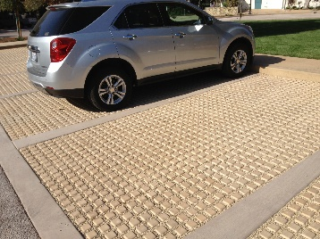

**Caption:** Porous pavement can be exposed or designed to have a full covering of grass above it. Photo Courtesy of Soil Retention.

**END OF CASE STUDY #1**

**Outdoor Rooftop Spaces** (Bison) **Section_Sub-Head_1** Outdoor spaces don’t always need to be on the ground, rather, they can be located on borrowed spaces on rooftops, terraces, etc. Recognizing this, architects can create safe and secure areas for learning on rooftop decks. Such innovative spaces can be utilized for learning labs, gardening, science experiments, reading areas and for exercise. They can also help to maximize the useable space of the building footprint, particularly in urban areas where schools tend to be built up vertically rather than out horizontally. They can also provide some mitigation to the heat island effect by using plantings and other light reflecting materials and surfaces.

The technical issue with creating such roof top spaces is two-fold. First, the primary purpose of a roof is to maintain a water proof barrier to weather, meaning that any roof deck system needs to avoid penetrations or damage to the roof. Ideally it would actually help protect the roofing membrane and add to its longevity while still allowing water to properly drain from the deck, onto the roof, and into the drainage system. The second issue is that even low slope roofs are still sloped and decks want to be level. Hence, an adjustable support system that can accommodate varying heights and create a level deck surface is needed.

The building industry has responded with complete systems for creating rooftop environments that are functional, environmentally appealing, and suitable for outdoor learning. Available products include adjustable pedestals that sit on top of the roof membrane and compensate for the roof slope and height change at the same time. The pedestals typically support a variety of different surface materials including wood tiles that can be certified by the Forest Stewardship Council (FSC) for sustainability. Such tiles sit on the pedestals and provide a stable and natural surface for pedestrians to walk on and other things such as planters, benches, or gardens to be placed upon.

**Photo #3**

**CASE STUDY #2 – Rooftop Spaces at the Girls’ School of Austin**

An excellent example of this approach being fully integrated into the design of a school is The Girls’ School of Austin, Texas which was founded in 2002. This private school provides an intellectually challenging education for girls in a supportive and creative environment. The campus was constructed to accommodate the growing needs of the school with a 12,400 square foot facility made up of a multi-purpose building, art and science classrooms as well as multiple gardens and play areas throughout the campus. Of particular interest were the creation of outdoor learning spaces that offered an environmentally sensitive solution and the opportunity for environmental education. As such, the outdoor environment makes up from than 60% of the campus, and includes well designed, sustainable courtyards and rooftop decks. The rooftop deck, made with wood deck tiles and adjustable supports have proven to provide a unique alternative educational space for outdoor learning.

**Photo CS #2**

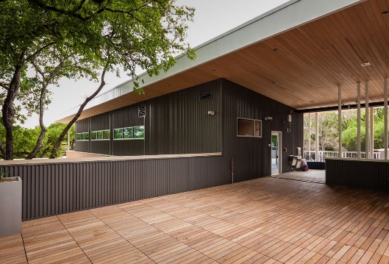

**Caption:** Roof decks at The Girls’ School of Austin, Texas provide outdoor learning spaces integrated into the campus. Photo Courtesy of Bison Innovative Products

**END OF CASE STUDY #2**

**Energy and Atmosphere (EA) Section_Head**

The Energy and Atmosphere aspects of LEED are probably the best known and rightly so since they are typically weighted to carry the most points in the rating system. The prerequisites and credits of this category address the reduction of energy consumption through a performance-based approach allowing designers and facility managers to tailor energy reduction measures to their specific buildings. Improving the energy performance of facilities is well known to lower operating costs, reduce pollution, and enhance occupant comfort which can lead to healthier, happier students, teachers and staff.

**Building Envelope** (NUDURA) **Section_Sub-Head_1** The most cost effective and highest potential for controlling energy use in a building starts with the design of the building envelope – the place that architects typically have the most direct control over. For schools, that usually means a reliable, high performance system is needed to prevent heat loss, eliminate thermal bridging and provide safety and comfort over the operating lifetime of the facility. This is particularly true in the exterior wall system selected for a school building.

An alternative high performance option instead of common steel framed, block or brick walls is catching on through the use of insulated concrete forms (ICFs). Such systems start with pre-formed rigid insulation in the shape of large, hollow “blocks” that can be straight, cornered, or custom configured. The inner and outer layer of insulation are held apart by connectors with low thermal conductance spaced appropriately. The hollow area is then filled with concrete once the ICF blocks are in place with the connectors serving as form ties and providing support to locate reinforcing steel. Once the concrete is set, the system provides a solid, durable concrete wall that is covered inside and out with continuous insulation creating a very efficient thermal wall envelope. The interior and exterior can then be finished in conventional manners of choice.

By designing and building with ICFs buildings can achieve high performance values by vastly reducing air infiltration due to the continuous nature of the walls. The system also offers superior performance when it comes to eliminating thermal bridging, resulting in even temperatures throughout the building with reduced drafts and cold spots to optimize energy performance. An added benefit is that insulated concrete forms act as an effective sound barrier, by dampening sound vibrations from unwanted outside noise, such as traffic, trains and neighbors. Since the main structural element in an ICF building is reinforced concrete, it offers substantially better durability and requires less maintenance and repair over its lifetime compared to some other systems.

**Photo #4**

**CASE STUDY #3 – Building Envelope at the Richardsville Elementary School**

The Richardsville Elementary School, a 77,285 sq. ft. school located in Bowling Green, Kentucky, was built using concrete filled ICF blocks and has been noted for setting green school building standards in the United States. Utilizing Insulated Concrete Forms for the high performance building envelope in conjunction with solar panels on the roof, Richardsville Elementary is able to harvest enough energy to offset the total energy consumed by the school, sending 300kw of power back to the grid and achieving a “net-zero” footprint. The high performance building envelope is key to this success and is designed to use only 18 kBtu/sq. ft. This is impressive energy conservation reflecting 75 percent less annually than the ASHRAE 90.1 design standard for elementary schools. By means of comparison, the average monthly utility bill for an elementary school in the United States is approximately $7,000. Richardsville generated enough solar energy (in 8 sunny days in the course of a month) that they covered over $4,300 in utility charges and received a credit of $300 for selling the energy back to the electric company.

**Photo CS #3**

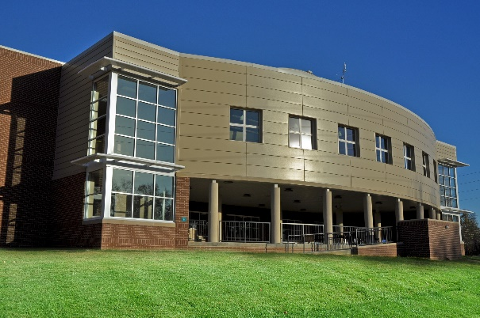 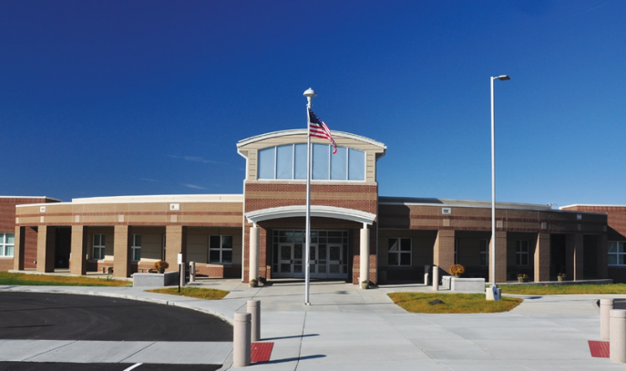

**Caption:** The high performance, net-zero Richardsville Elementary School designed by Sherman Carter Barnhart Architects of Lexington, KY was built using insulated concrete form walls. Photo Courtesy of NUDURA Integrated Building Technology

**END OF CASE STUDY #3**

**Heating and Cooling Systems** (Mitsubishi) **Section_Sub-Head_1** Conventional HVAC systems have served the needs of most buildings for many decades. However, achieving high levels of performance often requires going beyond the conventional. Considerable success has been found in the use of Variable Refrigerant Flow (VRF) systems which operate in a zoned manner as an energy-efficient method of providing precise comfort control to indoor environments. Zones are defined as single or multiple room spaces that are conditioned to a set temperature and are operated independently from other rooms within the same structure.

VRF systems move conditioned refrigerant directly to the zone to be cooled or heated, allowing the temperature of that area to be more precisely controlled. They can simultaneously cool some zones while heating other areas or just provide comfort control to zones that are in use. Some VRF systems do not require ductwork for heating and cooling thus providing more building design flexibility, which can result in more usable space. Ducted systems allow multiple rooms or a large open area to be combined into a single zone. Either way, VRF systems are often simpler in design and more energy efficient than conventional HVAC systems due in part to inverter-driven compressor technology which is highly responsive and efficient. The systems overall allow for compact, quiet units, flexibility of placement and gives architects and owners more design freedom with individualized controls.

VRF systems tend to differ from conventional HVAC systems in three ways: low noise levels, design flexibility, and long-term reliability and efficiency of the systems. The very quiet operation (as low as 19 decibels) leads to uninterrupted learning within classroom environments. The design flexibility and potential space savings means more attention can be placed on school design while indoor air quality is enhanced through the elimination of ductwork, providing a higher indoor air quality to the classroom. The efficiency and long term reliability speak to the green school needs for energy performance and sustainability with personalized comfort control enabling each classroom to operate independently of the others.

**Photo #5**

**CASE STUDY #4 – Heating and Cooling with VRF at the Screven County Elementary School**  
The Screven Elementary School located in Sylvania, Georgia serves 1,400 pre-K to fifth-graders in a 143,000 square-foot facility that was built in 1989. William Bland, Superintendent of the Screven County School System, said, “There was no question about the need for a renovation of the HVAC system at the elementary school.” The original plan was to repair the old system but the cost of that work was going to be substantial and was not going to increase energy efficiency. The direction changed when Bland and other school representatives learned about VRF systems. Mike Dixon, Maintenance Director said, “It was the energy efficiency that grabbed our attention. We were also interested in the ability of the units to maintain the temperature within one or two degrees and the quiet operation.” Choosing one make over other brands involved comparing attributes and offerings. “We talked with several companies regarding the features, capabilities, controls and warranty before deciding on the right system for us to go with,” said Dixon.

The VRF system allows Preston Dees, director of school safety and energy manager, Screven County School System, to monitor and control the cooling and heating in each classroom. Dees said, “Now we’re on a control system and we can manage our energy usage.” “We were able to cut out another big part of our energy costs when we installed the new system because we were able to remove the old boiler and cooling tower,” Dees said. The boiler had provided heat, which was no longer necessary with the VRF system. “We saved about two-thirds on our gas costs, so we’ve saved on energy and gas.” Overall, the school has documented a 25 percent energy savings compared to the prior conventional system.

**Photo CS #4: - from Screven Elementary**

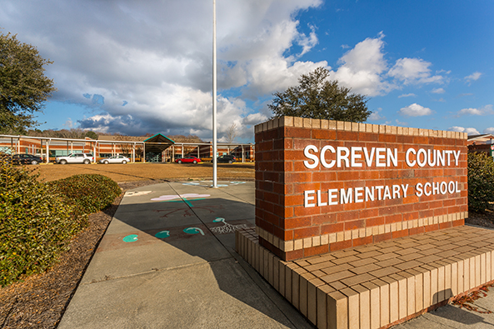 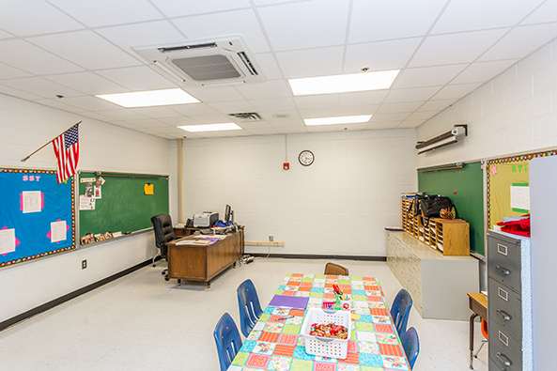

**Caption:** The Screven County Elementary School in Sylvania Georgia realized a 25 percent energy saving by switching from a conventional HVAC system to a VRF system. Photos Courtesy of Mitsubishi Electric Cooling & Heating *Joe Loehle Photography*

**END OF CASE STUDY #4**

**Materials and Resources (MR) Section_Head**

The Materials and Resources credit category of LEED focuses on two main issues: the environmental impact of materials brought into the facility and the minimization of landfill and incinerator disposal for materials taken out of the facility. The latest version places particular emphasis on the life cycle impact of the materials.

**Resilient Flooring Surfaces** (MONDO) **Section_Sub-Head_1** Schools are, by virtue of their daily student use, a very high foot traffic building type. As such, the choice of flooring materials for common areas such as hallways, large group rooms, and even individual class rooms is important in terms of long term wear and cleanliness. Resilient flooring is available in many forms with differing degrees of environmental impact. One that is being looked at more is rubber based floor coverings. These durable flooring surfaces have been installed in schools and universities worldwide in gymnasiums, weight rooms, indoor and outdoor tracks, multipurpose rooms, classrooms, lobby areas and locker rooms.

From an environmental standpoint, this type of flooring is available completely free of many of the things that designers are trying to keep out of Green Schools such as PVC, chlorine, and heavy metals. That means this material doesn’t rely on those materials during its manufacture nor detract from a healthy indoor environment once it is in place. During its useful life, rubber flooring products are well known for reducing significantly the need for chemical cleaners for maintenance, further protecting the health of school occupants. At the end of its service life, it is also 100 percent recyclable allowing it to become a new product and start a new service life. Because of its long life expectancy and lower maintenance costs, including the elimination of the need for waxing, rubber flooring is often shown to have a very low total life cycle cost.

Beyond the attributes already mentioned, rubber flooring contributes in other ways to a positive school environment. It is a non-porous, durable material with outstanding wear and abrasion resistance as well as stain and chemical resistance. It is dimensionally stable without the need to weld seams and can carry high static or rolling loads. From a human perspective, it provides a comfortable walking surface, some sound deadening properties, and can even be specified with antibacterial / antimicrobial qualities. For safety, it has been shown to meet ADA slip resistance requirements and is commonly Class 1 fire rated.

**Photo #6**

**CASE STUDY #5 – Resilient Flooring at Holy Cross Catholic Elementary School**

A good example of incorporating green materials is the Sudbury Catholic District School Board in Ontario, Canada, which celebrated the grand opening of the pre-K to grade six Holy Cross Catholic Elementary School in September 2012. Students, faculty and community members were pleased to see the state-of-the-art technology, eco-conscious design and equipment, vivid colors and a solar collection system that was incorporated on the roofs of the new school. “With the modern technology and architecture, the Holy Cross Elementary School embodies the latest ideology for schools of the 21st Century,” says Denis Faucher, manager of facility services.

In order to maintain a sanitary environment for the young students, 3mm thick rubber flooring was installed throughout the school. Its anti-bacterial, anti-microbial properties are not only beneficial on a health level, the attractive colors made for eye-catching designs. “We used a lot of color cueing and created large patterns in the floor for direction,” says Amber Salach, project architect and lead design with Yallowega Béllanger Architecture. Faucher agrees. “There are several reasons we decided to install rubber flooring. From a budget factor, the floor is low maintenance and it is environmentally friendly. There is no need for harsh chemicals in the cleaning process. We also know that this product is recyclable.”

**Photo CS #5: - from Holy Cross Catholic School**

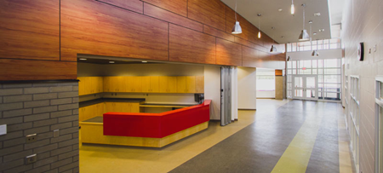

**Caption:** From the moment people walk through the front doors of the Holy Cross Catholic Elementary School they know they are in a special place. Photo courtesy of MONDO

**END OF CASE STUDY #5**

**Wall Surfaces** (Construction Specialties) **Section_Sub-Head_1** Adding visual interest or educational information to walls in schools has been a long-standing design objective. However, if school walls could talk, they would describe constant contact with students’ backpacks, computer bags and feet as well as tough blows from mobile classroom carts. These occurrences can cause scrapes and dents on wall surfaces and corners. Because of the abuse they receive, walls in classrooms, hallways, gyms and cafeterias must be durable and easy to clean, requiring little to no maintenance. They must also be manufactured from material that is environmentally sound and maintains safe indoor air quality.

Until now, designers and architects have struggled to incorporate patterns and high-resolution graphics onto walls in busy school environments. In many cases, design and durability have been compromised with the use of limited-offering, Type-II (i.e. medium duty) vinyl wall coverings with graphic patterns or solid color or wood-grain materials that don’t withstand the extensive abuse. That has changed since new product offerings deliver all the functional elements required of walls in schools without compromising style. In fact, custom photos, wayfinding, mascots, logos and other art can now be preserved on walls behind impact-resistant, environmentally preferable, rigid PETG (Polyethylene Terephthlate Glycol-Modified) plastic material that is PVC-free and contains no PBTs and no halogenated or brominated fire retardants. Such a protective material acts as a shield that safeguards against damage while making cleaning easy, so walls look great during use.

The high performance capabilities of a PETG protective wall covering means that the art has staying power in schools. “The hallways of our school get an A+ for design, function and durability,” said Steven Fleming, Principal of Pasadena Independent School District’s new Dr. Kirk Lewis Career & Technical High School in Texas. “Students are motivated and energized before they even enter the classroom. We rest easy knowing that custom walls can stand the test of time and of school wear and tear.”

**Photo #7**

**CASE STUDY – Wall Surface Graphics at Gardens Elementary School**

When the Pasadena Independent School District sought a new building to replace the original Gardens Elementary School, built in 1944, a central focus was placed on celebrating the strong school pride shared by its 700 students and 85 faculty members. Though the modern facility would look very different from the previous one, respect for the school’s heritage and enthusiasm for learning would always remain at Gardens Elementary. With this in mind, the design team, headed by SBWV Architects, Inc., decided to cover the school’s entrance wall with an enormous mural of its mascot.

On Gardens Elementary School’s opening day in the winter of 2014, the students enthusiastically ran to touch the Garden Gator on the entrance wall as they arrived at their brand new school. Embedded behind impact-resistant, PVC-free rigid PETG material, the high-resolution art has its own clear, protective shield that safeguards it against damage and makes cleaning easy. “The mural was the final touch to our new school and the protective covering allowed us to get the kids excited about the fresh start,” said Israel Grinberg, Pasadena Independent School District Construction Manager.

**Photo CS #6:**

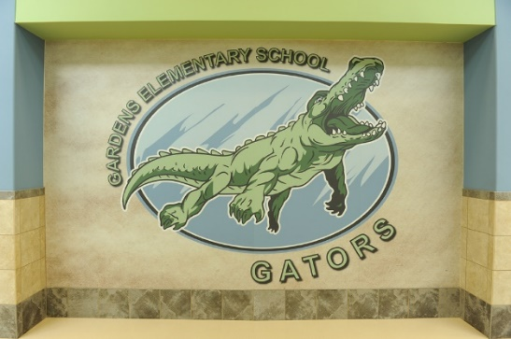

**Caption:** The Pasadena Independent School District in Pasadena Texas used a PETG protective covering to create a large mural of the school mascot. Photo Courtesy of Construction Specialties, Inc. *Photo Credit: Jack Opatrany*

**END OF CASE STUDY #6**

**Access Control** (DORMA) **Section_Sub-Head_1** Schools require a lot of doors. They also require security at many or even all of those doors in the interest of safety which is regularly on the mind of all school administrators and Green School advocates. Further, exterior doors need to be able to seal tightly shut for energy conservation purposes but be easy to open and exit in all circumstances. Controlling the operation of doors then, is to control the flow of people coming into or exiting the building while still meeting other needs. The means for achieving that often comes down to selecting both electronic and mechanical access control products that meet or exceed the requirements needed for K-12 schools.

Manufacturers of door control devices recognize both the common and unique demands of schools and offer a wide range of products accordingly. Electronic stand alone and wireless cylindrical and mortise locks are hot items with many school designers and managers since they can help secure doors remotely. Manual systems are still predominant requiring key access with sophisticated systems in place to establish master keys, sub-master keys, etc. The trick to using both electronic and manual systems in the same building is the coordination between them, which means finding one manufacturer that does both should make everyone’s life easier. Exit devices using concealed or surface mounted hardware are usually paired with door closers all with a particular eye towards a consistent look and performance level throughout the facility. Door lever designs that are compliant with handicapped accessibility requirements and good security are often consistent between different series of products, from mortise to cylindrical, and finishes can be consistent for all category of products. But often it is the hardware performance over time that is of most interest with warranties and serviceability playing large roles in decision making selections.

**Photo #8**

**CASE STUDY #7 – Access Control at Cherokee Central School**

The architectural firm of Padgett and Freeman Architects, PA in Asheville, North Carolina designed the Cherokee Central School, in Cherokee, NC with green design and security in mind. The Eastern Band of the Cherokee Nation witnessed a dream come true when K-12 students began the school year in a new $108 million, 473,000-sq-ft complex. The Cherokee Central School is an all-encompassing campus with three schools, three gyms, an auditorium, community center, sports arena, cafeteria, and an array of state-of-the-art athletic fields.

The Cherokee Central School is one of the largest green schools east of the Mississippi. According to Caramaleta Monteith of the tribe’s school board, awareness of the School’s green features is built into cultural and environmental education so students will learn what it means to be “green” from direct experience.

From the outset, the school was designed to achieve LEED Silver Certification. The list of green techniques and products used in construction is a long one. Thinking green started with how the structure would lie on the land and respect its natural surroundings. Energy conscious construction decisions followed. Passive solar heating and daylighting were designed into the buildings. A geothermal system provides heating. Captured rainwater contributes to water supplies used to flush toilets and irrigate the grounds. 90 percent of construction waste was recycled.

In the interest of providing a safe, controlled learning environment, a variety of architectural hardware products were installed on internal and external doorways throughout the schools thus contributing to energy conservation, while providing durability, strength, reliability, and security. Closers, exit devices, pivots, locksets and keys, dead bolts, power supplies, and electro-magnetic door holders were all coordinated to work together to ensure that doorways are safe, secure, easy to use, and long lasting.

**Photo CS #7**

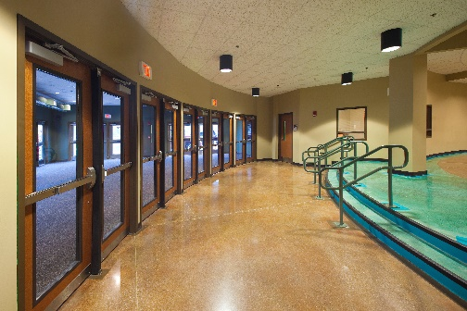

**Caption:** The Cherokee Central School combines green school features with coordinated architectural hardware for mechanical and electronic access control. Photo Courtesy of Dorma, USA, Inc.

**END OF CASE STUDY #7**

**Indoor Environmental Quality (IEQ) Section_Head**

Indoor Environmental Quality address concerns relating to indoor air quality, occupant’s health, safety, and comfort, air change effectiveness, and air contaminant management. The IEQ credit category seeks improvements to ventilation, indoor CO2 levels, daylighting, lighting quality, and thermal comfort – all of which have the potential to impact occupant health and performance.

**Adhesives and Air Quality** (Bostik) **Section_Sub-Head_1** While it is easy to think about the things we see in a building and how they affect air quality, there are also many products or materials that we don’t readily see in a finished space that are important too. LEED certification seeks that all materials, including those not seen, address their chemical make-up and their potential impact on human health by limiting or eliminating such things as volatile organic compounds (VOCs). One such unseen but prevalent product is adhesives which can be used throughout a school building to secure many products in place.

By way of example, let’s look at wood flooring that may be used in a gymnasium or perhaps be existing in a school. If the wood is placed over concrete, then an appropriate underlayment and adhesive may be the best way to install it. The selection process for the adhesive must address not only a long-lasting, durable bond, but also the ability to stand up to heavy foot traffic. There may be other considerations too such as moisture protection from the concrete and sound mitigation from footsteps on the floor.

At least one manufacturer has recognized the variety of needs and combines high strength adhesive, moisture barrier, and sound abatement underlayment all in one low VOC product. The goal is to provide a safe installation so parents, teachers, and students don’t have to worry about a school’s gymnasium flooring de-bonding from its substrate, possibly causing safety hazards to students walking, running, or exercising on top of it. A concurrent goal is to maintain good indoor air quality in the space through low VOC content. Going further, the adhesive not only firmly grips wood flooring to the substrate, it protects the floor from damaging moisture vapor which could cause deterioration, leveling problems, fissures and even mold which could be harmful to those using it day-to-day.

According to Ron Winterton, Sales Manager of Intermountain Wood Flooring, a major supplier to the architectural & design community in the Pacific Northwestern states, “Not only do all-in-one products like these offer excellent moisture protection, they provide sound abatement properties equivalent to 1/4" cork underlayment.” He also recognizes the importance of manufacturer’s systems that help ensure the required thickness of the adhesive membrane is maintained, even if installers walk on the flooring before the adhesive has cured.

**Photo #9**

**CASE STUDY #8 – Flooring Adhesive in a Large School**

Susan Heller of HY Floor and Gameline Painting, Inc. was overseeing work on the renovation of a large school's sports center. During the project they were requested to redo one of the adjacent rooms, which had been originally fitted with wood flooring but was recently damaged due to water intrusion. “There were two or three inches of water sitting on the wood floors, it was just unbelievable to look at,” said Heller. “Workers were able to get all the water off the floor but it’s very hard to dry your slab, and in some places the moisture was still very high.”

According to Heller, the company was faced with a decision to either do the project with a separate moisture mitigation system, an option that would take more time than their tight deadline would allow, or to find another product to solve the problem. HY insisted on using an all-in-one adhesive state-of-the-art product which provides moisture protection, sound deadening, crack isolation and mold protection. It also incorporated a spacer system to ensure proper membrane thickness between the hardwood and substrate.

“The all-in-one system offers such good adhesion plus it’s easy to work with on both horizontal and vertical surfaces,” said Heller.

**END OF CASE STUDY #8**

**Daylight** (Pittsburgh Corning) **Section_Sub-Head_1**The use of natural daylight in school buildings is not only desirable from a general indoor environment point of view, it has also been shown to positively improve the comfort, health and learning abilities of students. Building designers often think first of glass to achieve daylighting goals, which is often appropriate, but glass block is another time-proven, durable option. Glass block can be used in both interior and exterior applications, it is inert, low maintenance and highly durable. Glass block’s myriad of performance characteristics make it a superior choice for school construction by providing daylighting, security, sound control, and controllable levels of privacy. Plus new glass block systems also can be a part of the building envelope to protect against outside forces all without giving up daylighting. New energy efficient glass block can also provide improved insulation and solar heat gain values which can meet or exceed energy conservation from other glazing options.

While glass blocks are traditionally specified in Division 4 masonry applications, there are new glass block systems that are engineered and pre-fabricated for use in Division 8 applications. These pre-fabricated high performance systems have been tested to meet enhanced performance requirements and are resistant to hurricanes, tornadoes, blasts of force, and ballistic attacks. All of these systems also provide daylighting, privacy and security and contribute to LEED and sustainability. For interior applications, custom decorated glass blocks can complement the design of the school by providing subject specific décor to enhance the learning experience of students. Plus they are easy to install which improves efficiency by reducing labor at the jobsite.

**Photo #10**

**CASE STUDY#9 – Daylighting with Glass Block at River Crest Elementary School**

The River Crest Elementary School in Hudson, Wisconsin featured glass block prominently and helped the building earn LEED Gold certification. At 93,450 square feet, River Crest Elementary School is Hudson's sixth elementary school with a capacity for 588 students in grades kindergarten through fifth. Commissioned in 2006, this elementary school was to be a highly sustainable and innovative education center built to reflect the natural topography as it relates to its setting. With an environmental theme that reflected the school district's vision of a sustainable learning environment, River Crest Elementary was created with healthful, day lit spaces, improved energy and water efficiency, and decreased operational costs while emphasizing environmental education.

Hoffman Planning, Design & Construction, Inc., a Total Project Management firm, made it their mission to achieve one of the school’s primary goals – becoming a sustainable model for the community. Catherine Cruickshank, Senior Project Designer at Hoffman, was inspired to experiment by using glass blocks that were twisted and turned to create waves and ripples consistent with the River Crest theme while achieving a balance between daylight and privacy. The glass blocks also enabled the elementary school to overcome the prerequisite challenge of acoustics to ensure classrooms are quiet enough for learning. With sustainability and privacy a guiding factor, Cruickshank added glass blocks to the Guidance office, computer room and story area, and cafeteria. The glass block allowed natural light into the areas providing bright spaces that restrict noise and offer improved visual capability. “Initially we were concerned about the acoustics in the guidance office, but the glass block worked out great,” said Cruickshank. “It let light into the space while providing privacy for conversations with students.”

**Photo CS #9**

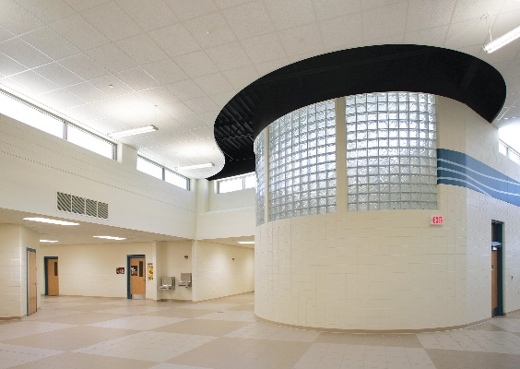 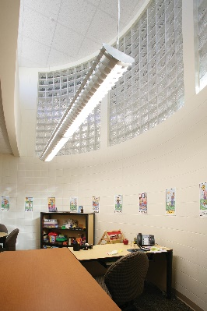

**Caption:** In the main foyer of the River Crest Elementary School, patterned glass blocks create waves introducing light from the windows into the guidance office while still providing acoustical privacy. Photo Courtesy of Pittsburgh Corning Glass Block

**END OF CASE STUDY #9**

**Enhanced Acoustics** (AMBICO) **Section_Sub-Head_1** We have touched on the fact that LEED for Schools has both pre-requisites and credit options for acoustical control in schools. The goal is: “To provide workspaces and classrooms that promote occupants’ well-being, productivity, and communications through effective acoustic design”. When looking to achieve that goal, architects often look at walls and floor / ceiling assemblies for things such as sound transmission class (STC) ratings. The means to achieve those ratings are fairly well known although some innovations continue to occur.

When looking at classroom walls designed for acoustics in schools, it is important to address the doors leading into those classrooms. Sound from a corridor may be thwarted by a wall assembly properly designed to mitigate sound transfer, but if the door is not also addressed, the end result will be poor. Since sound is energy and behaves the same way as other energy, this would be the equivalent of building a very energy efficient exterior wall and then putting a very leaky window in it which would undo most of the effort put into the wall.

Fortunately, it is possible to specify doors and frame assemblies with high STC ratings. However that is not where things end. The door, frame, and related door components all need to be looked at and addressed in order to achieve satisfactory results. To do so using individual products and components is theoretically possible, but functionally nearly impossible. The more direct solution is to specify complete door and window frame systems that are coordinated and independently tested for sound control. In this way STC ratings are dependent on doors and frames being supplied as complete assemblies from a single manufacturer rather than separate doors, frames, seal systems, glazing and hardware being supplied from different manufacturers. Typically, manufacturers of such complete systems can demonstrate acoustic performance as tested in accordance with ASTM E-330 “Standard Test Method for Structural Performance of Exterior Windows, Doors, Skylights and Curtain Walls by Uniform Static Air Pressure Difference” and ASTM E-413 “Classification for Rating Sound Insulation.”

**Photo #11**

An additional consideration when looking at door and window frames is safety in regard to extreme weather. Many schools in certain areas of the country experience the threat of tornados giving rise to the need for tornado safe rooms. Door frame and hardware assemblies along with window frame and glazing assemblies on perimeter shelter walls need to be capable of resisting the forces imposed on it and protecting the critical life safety of the inhabitants. Such door and window assemblies are available and can be specified as tornado resistant openings shown to be tested in accordance with FEMA 361 & 320 and ICC-500 standards.

**Innovation in Design or Operations (IN) Section_Head**

All LEED rating systems have always left room for innovation and creativity in meeting the objectives and intent of the program. As such, credits are sometimes earned by recognizing projects for innovative and exemplary technologies, methods, project planning, and project execution.

**Flexible Space** (NanaWall) **Section_Sub-Head_1** A popular topic in 21st Century school design is the creation and use of flexible space – space that can be used for multiple purposes or modified to suit variable needs. This approach is generally regarded as an innovative way to carry out education while staying nimble in the use of space in a school. But it can also be a very green design approach if it allows building square footage to be reduced by combining and consolidating activities that might otherwise need totally separate rooms. Less square footage means less space to heat and cool, less material to incorporate, and less environmental impact overall. It doesn’t mean having to do with less program space, however, it just means being smarter about how it is created and used.

One successful approach toward creating such flexible space is the use of movable wall panels, often with glass or glazing to enhance visibility and daylighting. By incorporating such movable walls, some fixed walls of a traditional classroom can be eliminated either by creating a shared space between two classrooms or by opening up to a common area that is shared by multiple classrooms or grades. It is also possible to create areas for project-based learning or common areas where students can work together on a range of activities, utilizing shared resources such as technology centers and presentation areas.

Creating a flexible classroom configurations optimizes the floor space within the building envelope which translates into reduced construction costs. In addition, the multi-use spaces also can contribute to reduced operating costs as teachers can share resources and cross-collaborate, creating a more efficiently run school environment.

**Photo #12**

**CASE STUDY #10 – Flexible Space at the Carrie Busey Elementary School**

This movable, flexible wall approach was employed at the Booker T. Washington STEM Academy in Champagne, Illinois. Serving 225 students, the school is separated into three academies with each grade further stratified into three learning studios which share a communal gathering space. The architectural firm of Cannon Design determined that the use of movable glass wall systems allowed the three studios to either function as separate learning environments or to open up and share the larger communal space. Stuart Brodsky, AIA, LEED AP, an associate principal at CannonDesign has noted “Movable glass walls enable multiple room configurations and sizes without building additional space. This flexibility allows teachers to gain access to shared resources and adapt space for small and large groups as well as project-based learning activities.” They also allow each learning studio to maximize activities within the communal gathering and project workspace—what Canon Design calls a “piazza for discussion and collaboration.” This open-plan layout is meant to mirror professional settings helping students prepare for real world future collaborations.

In the end, this innovative approach to school design using movable glass walls to create flexible space can translate into more creative learning environments that boost student performance.

**Photo CS #10**

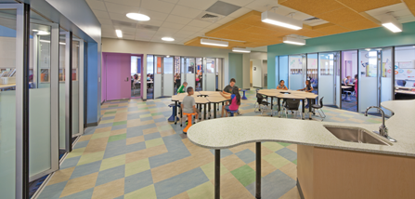 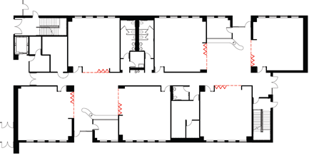

**Caption:** At Carrie Busey Elementary School, the communal floor plan design allows both cross-classroom and cross-grade collaboration. Teachers can conduct learning activities while monitoring the shared area. Photo Courtesy of NanaWall Systems

**END OF CASE STUDY #10**

**Conclusion Section_Head**

There are certainly countless ways to achieve the design, construction, and operation of schools in a manner that is consistent with the three-fold goals of Green Schools: zero environmental footprint, a positive impact on occupant health and performance, and environmental literacy. Understanding the options and some of the materials and systems currently available, including those discussed in this article, can help design professionals, construction teams, facility managers, educators, and administrators achieve these goals successfully.

Approximately 7,700 words to this point

**Author Bio:** (to appear at end of article)

***Peter J. Arsenault, FAIA, NCARB, LEED-AP*** *is an architect and green building consultant who has authored over 120 continuing education and technical publications as part of a nationwide practice* [*www.linkedin.com/in/pjaarch*](http://www.linkedin.com/in/pjaarch)

QUIZ

1. The green schools community, both in the U.S. and around the world, is aligned toward:

a. zero environmental footprint (including energy, water, and waste)

b. a positive impact on occupant health and performance

c.100% of graduates demonstrating environmental literacy.

d. All of the above

1. Non-pervious material, such as asphalt or concrete, can cause all of the following EXCEPT:

a. water runoff

b. water to readily drain into the ground

c. flooding

d. water pollution issues

1. The two technical issues that must be addressed with roof deck systems are:

a. avoid penetrations or damage to the roof and accommodate varying heights to create a level deck

b. reflect sunlight and collect water

c. insulate the roof and allow ventilation

d. work with the building design and offer material choices

1. An alternative high performance option for thermally efficient walls is the use of:

a. common steel framed walls

b. insulated concrete forms (ICFs)

c. block walls

d. brick walls

1. VRF systems tend to differ from conventional HVAC systems in each of the following ways EXCEPT:
2. low noise levels
3. design flexibility
4. lower energy efficiency
5. long-term reliability
6. During its useful life, rubber flooring products are well known for reducing significantly the need for chemical cleaners for maintenance, helping to protect the health of school occupants.

a. True

b. False

1. Custom photos, wayfinding, mascots, logos and other art that withstand the extensive abuse of schools can now be preserved on walls using:

a. Type-II vinyl wall coverings with graphic patterns

b. solid color panels

c. impact-resistant, environmentally preferable, rigid PETG

d. wood-grain materials

1. It is possible to specify a wood floor adhesive that combines high strength adhesive, moisture barrier, and sound abatement underlayment all in one low VOC product.

a. True

b. False

1. Glass block’s myriad of performance characteristics make it a superior choice for school construction by providing:

a. daylighting

b. security

c. sound control, and controllable levels of privacy

d. All of the above

1. Creating a flexible classroom configurations optimizes the floor space within the building envelope which translates into reduced construction and operating costs.

a. True

b. False

**Quiz Answer Key**

Question Answer

1. D  
2. B

3. A  
4. B

5. C   
6. A

7. C   
8. A

9. D  
10. A

**Photos and Captions:**

**Cover Photo**



**Caption:** Lady Bird Johnson Middle School in Irving, Texas, is the first net-zero school in that state and at 150,250 square-feet, the campus is the largest net-zero educational facility in the country. A net-zero building produces as much energy as it consumes, so its overall energy consumption is net zero over the course of a year. Architect: Corgan Associates, Inc. Photo courtesy of MONDO

**Photo #1**

  

**Caption:** The Center for Green Schools provides a full range of information and resources for architects and other design professionals engaged in the creation of green and sustainable schools. Images courtesy of the Center for Green Schools at the U.S. Green Building Council

**Photo #2**

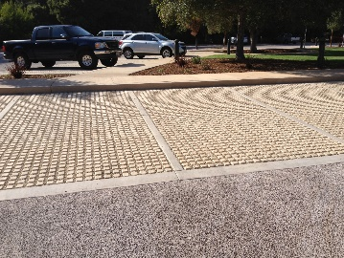

**Caption:** Laguna Blanca School in Santa Barbara, CA used permeable concrete pavers to provide environmentally friendly parking around this K-12 school that addresses water run off on site. Photo Courtesy of Soil Retention.

**Photo #3**

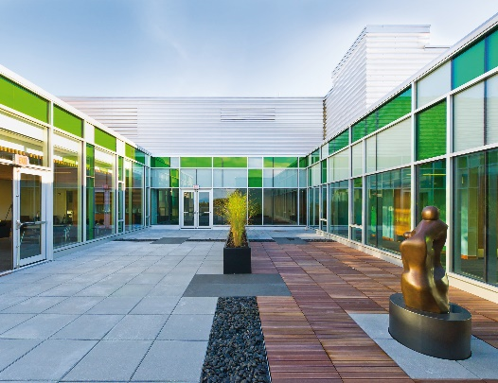 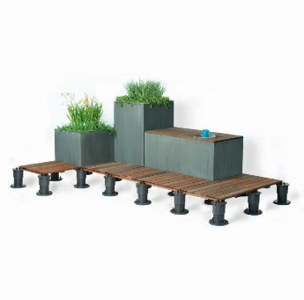

**Caption:** Roof top spaces can be used for outdoor learning environments when a system is selected that is specifically designed to work with the roof membrane, create a level surface, and meet all functional requirements for design and drainage. Photo Courtesy of Bison Innovative Products

**Photo #4**

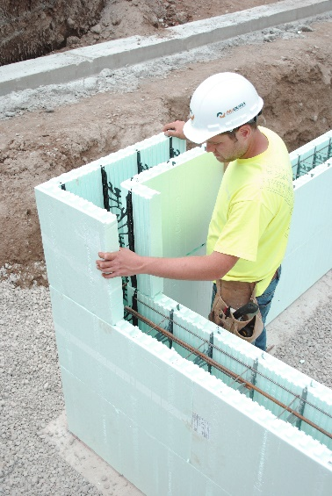

**Caption:** Insulated concrete forms (ICFs) achieve high energy efficiency and provide other attributes such as sound deadening and durability in green schools. Photo Courtesy of NUDURA Integrated Building Technology

**Photo #5: - from Screven Elementary *place together as 3 cropped close ups**

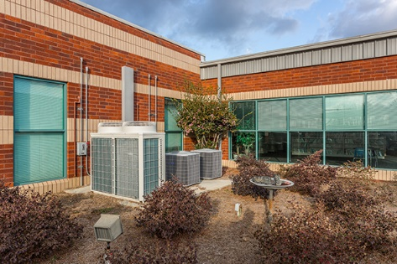 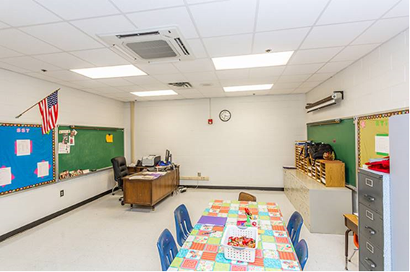 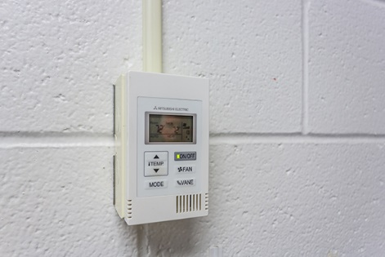

**Caption:** A VRF system is an energy efficient alternative to conventional HVAC systems using high performance compressors, ductless or ducted indoor units, and individual zone controls. Photos Courtesy of Mitsubishi Electric Cooling & Heating *Joe Loehle Photography*

**Photo #6: - from Oklahoma Public Schools**



**Caption:** Rubber flooring surfaces are resilient, highly durable, easy to maintain, and environmentally friendly making them ideal for many school applications. Photo courtesy of MONDO

**Photo #7:**

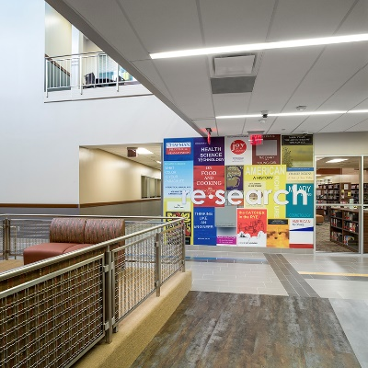

**Caption:** PETG protective coverings allow for art, information, wayfinding, and other custom or standard graphic information to contribute to the learning environment while staying protected from damage. Photo Courtesy of Construction Specialties, Inc. *Photo Credit: Shau Lin Hon, Slyworks Photography*

**Photo #8**

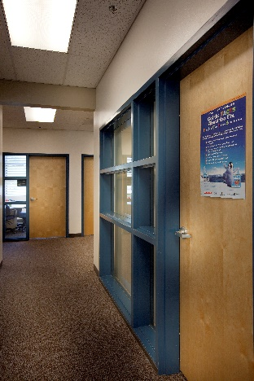

**Caption:** School security is an important consideration that usually involves coordination of electronic and mechanical hardware in Twenty First Century school design. Photo Courtesy of Dorma, USA, Inc.

**Photo #9**

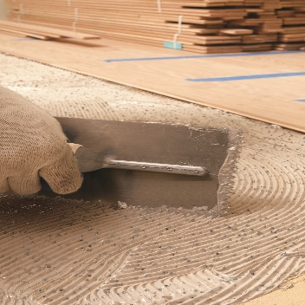

**Caption:** All-in-one wood floor adhesives are available in low VOC formulations that also provide moisture protection, sound deadening, and mold protection. Photo Courtesy of Bostik, Inc.

**Photo #10**

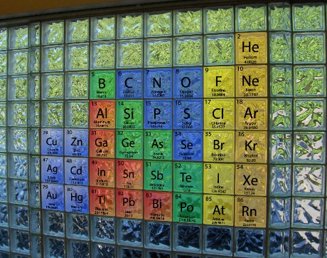 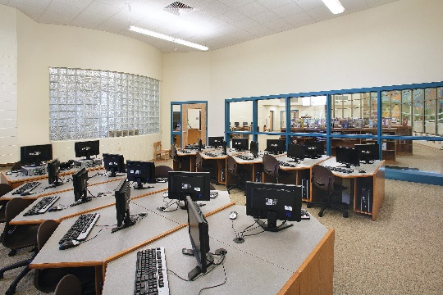

**Caption:** Glass block can be customized with messaging or artistic designs to enhance or complement the design of the building and classrooms. For example, a Chemistry lab can have a glass block wall with the Periodic Table of Elements on it. Clear or patterned glass block can also provide daylighting while enhancing the learning atmosphere of the classroom.Photos Courtesy of Pittsburgh Corning Glass Block

**Photo #11**

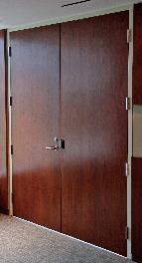

**Caption:** Specialized door, frame and window systems can be specified to meet performance standards and still feature aesthetic qualities such as this acoustic wood door and steel frame system achieving an STC rating of 51. Photo Courtesy of AMBICO Limited

**Photo #12**

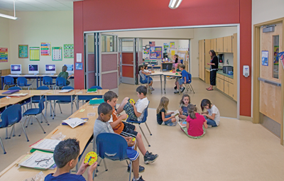

**Caption:** Flexible classroom configurations are an innovative way to maximize programming space while minimizing square footage and the associated costs of construction and operations. Photo Courtesy of NanaWall Systems